User Manual

**Asset Tracking System**



**Head Office**: C-64, Okhla Industrial Area – 1, New Delhi – 110020, India, Ph: +91-11-26816687

**Development Centre:** 75-C, Sector – 18, Udyog Vihar, Gurgaon, Haryana – 122001 INDIA

**Regional Offices**: Mumbai, Bangalore, Chennai, Kolkata

**Overseas Office:** Srilanka

**Notice:**

This document contains information, which is the proprietary property of Bar Code India Ltd. This document is received in confidence and its contents cannot be disclosed or copied without the prior written consent of Bar Code India Ltd.

Nothing in this document constitutes a guaranty, warranty, or license, express or implied. Bar Code India Ltd disclaims all liability for all such guaranties, warranties, and licenses, including but not limited to: Fitness for a particular purpose; merchantability; not infringement of intellectual property or other rights of any third party or of Bar Code India Ltd; indemnity; and all others. The reader is advised that third parties can have intellectual property rights that can be relevant to this document and the technologies discussed herein, and are advised to seek the advice of competent legal counsel, without obligation of Bar Code India Ltd.

Bar Code India Ltd retains the right to make changes to this document at any time, without notice. Bar Code India Ltd makes no warranty for the use of this document and assumes no responsibility for any errors that can appear in the document nor does it make a commitment to update the information contained herein.

**Copyright**

*Copyright © BCIL 2010. All rights reserved.*

**Trademark**

\*Other product and corporate names may be trademarks of other companies and are used only for explanation and to the owners' benefit, without intent to infringe.

Table of Contents

[Introduction 4](#_Toc345602223)

[System Prerequisite 5](#_Toc345602224)

[System Requirement 5](#_Toc345602225)

[DB Server 5](#_Toc345602226)

[Application Servers 5](#_Toc345602227)

[Desktop Computers 6](#_Toc345602228)

[Mobile Terminals 6](#_Toc345602229)

[Printer 6](#_Toc345602230)

[Start Up of Web Application 6](#_Toc345602232)

[**Home** 9](#_Toc345602233)

[**Master** 9](#_Toc345602234)

[Create Initial Details 9](#_Toc345602235)

[Category Master 10](#_Toc345602236)

[Company Master 11](#_Toc345602237)

[Department Master 12](#_Toc345602238)

[Employee Master 12](#_Toc345602239)

[Group Master 13](#_Toc345602240)

[Group Rights 14](#_Toc345602241)

[Location Master 15](#_Toc345602242)

[Process Master 16](#_Toc345602243)

[User Master 17](#_Toc345602244)

[Vendor Master 19](#_Toc345602245)

[**Asset** 19](#_Toc345602246)

[Import/Export Data 20](#_Toc345602247)

[Asset Acquisition 21](#_Toc345602248)

[Approve Assets 22](#_Toc345602249)

[Asset Allocation 23](#_Toc345602250)

[Asset Replacement 24](#_Toc345602251)

[Asset Transfer 24](#_Toc345602252)

[Gate pass Generation 26](#_Toc345602253)

[Sold/Scrapped Assets: 27](#_Toc345602254)

[Swap Assets 28](#_Toc345602255)

[**Support** 29](#_Toc345602256)

[Asset Reconciliation 29](#_Toc345602257)

[View Asset List 29](#_Toc345602258)

[View Asset AMC 30](#_Toc345602259)

[View Gate pass List 31](#_Toc345602260)

[Vendor call log management 32](#_Toc345602261)

[Vendor Escalation Matrix 33](#_Toc345602262)

[Document Management 33](#_Toc345602263)

[**Reports** 34](#_Toc345602264)

[Asset Allocation Report 35](#_Toc345602265)

[In Stock Report 35](#_Toc345602266)

[Tracking Report 36](#_Toc345602267)

[Summary Report 37](#_Toc345602268)

[History Report 39](#_Toc345602269)

[Dashboard Report 40](#_Toc345602270)

[Call Log Report 41](#_Toc345602271)

[Allocated Returnable 42](#_Toc345602272)

[Gate Pass Report 43](#_Toc345602273)

[Returnable Asset Report 44](#_Toc345602274)

[**Logout** 44](#_Toc345602275)

# Introduction

**Asset Tracking System** application is helpful in managing assets through web application at all the locations of the same company. The entire application deals with acquisition, allocation, replacement, transfer, declaration of scrapped or sold and swapping for all kinds of assets (Admin/IT) in an organization.

Various reports are incorporated in order to view assets’ current status and count for all categories in all locations at the same time.

The entire solution is divided into three parts:

**1.** **Intranet** **Web Application:** This application is used to create and manage masters, upload/update and manage assets’ data, viewing reports and to performing various other operations.

**2.** **Desktop Application:** This application is used to get barcode stickers printed on labels. Desktop application can be used for ADMIN and IT assets both as per user settings. User can view log of printing barcode and view unprinted assets’ details as well.

**3. Scanner** **Device Application:** This application works in batch mode to contain scanned asset codes and download scanned data to PC.

# System Prerequisite



# System Requirement

The following system requirements are as below:

## DB Server

The solution requires the high performance server with minimum following:

* Dual Core or better CPU
* Microsoft Windows 2000/2003 Server operating system.
* Microsoft SQL Data Server 2005/2008 for the data storage.
* Dot net Framework 3.5 installed
* Database specific memory to support approximately 30 users or more. (Minimum 4 GB DDR2 RAM)
* Storage space approximately 1.5GB data per month (could vary depending upon the volume of transactions, Minimum 160 GB HDD)

## Application Servers

The solution would require the high performance server with minimum following:

* Intel Pentium Dual Core or better CPU
* Microsoft Windows 2000/2003 Server operating system.
* Internet Information Server (IIS 6.0).
* Dot net Framework 2.0
* 100 mbps or high-speed redundant LAN card.
* DVD-ROM

## Desktop Computers

The desktop application requires the computer with following specifications:-

* Intel Pentium Processor with Windows XP operating System
* 512MB RAM
* Dot net Framework 3.0
* Basic network and switches wherever required to setup
* LAN Connectivity at each solution location

## Mobile Terminals

The HHT application requires Motorola MC3090 handheld with following specifications:-

* Microsoft Windows CE 5.0
* 32MB RAM; 64MB ROM
* Compact Dot net Framework 3.5 Preinstalled

## Printer

* Zebra TLP2844

# Start Up of Web Application

To log on **Asset Tracking System** web application, user needs to sign in by selecting the **Asset type (Admin/IT)** from the first drop down, **company/location** from the second drop down, entering *User Id* and *Password* into the relevant textboxes and clicking **Sign In** button.

If the user is authenticated successfully, the logged in user is redirected to HomePage, Otherwise, a warningmessage pops up saying “*invalid login and password”*.

**Note: The entire application functionality will be same for Admin type assets also.**

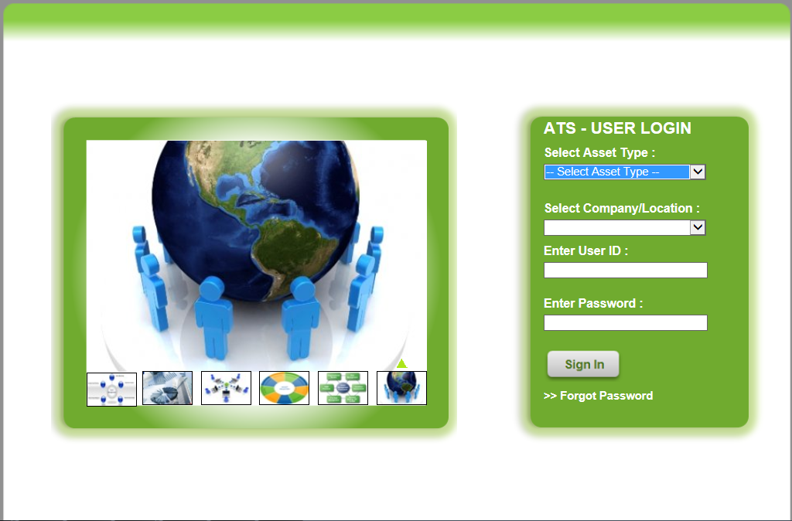

In case the user forgets the password he will click on forgot password link () after selecting **asset type** and **location** name, the page will be directed to **forget password** page. Here, the user will enter the ***User Id, email id*** and confirm ***Email Id*** into the relevant textboxes (e-mail should be registered already through in user master). On clicking submit, the password would be sent to the registered email id of the user. After getting the password, the user is redirected to login page by clicking on **“Click here to go to login page”.**

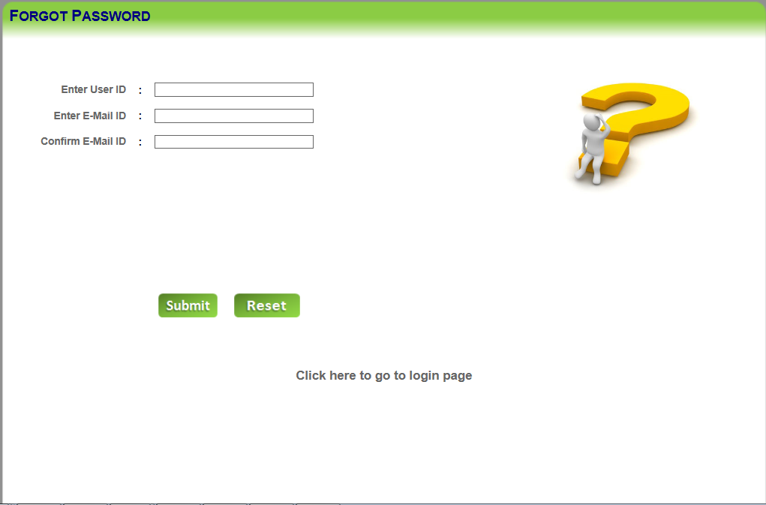

Once the user logins successfully, following home page would be displayed.

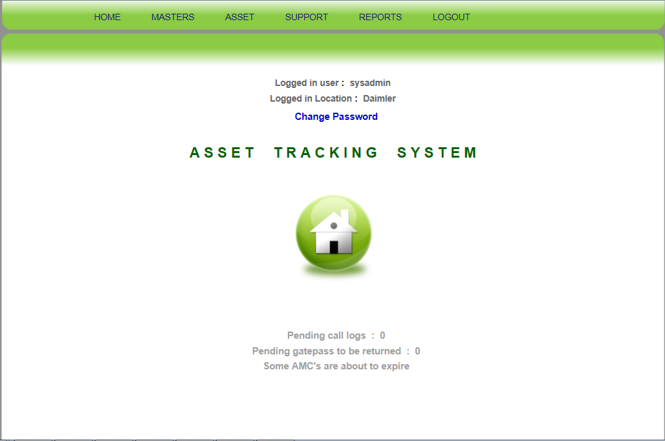

The home page contains **6 Main Menus.** There are **4 more options** *(“Change* *Password”, “Pending Call Logs”, “Pending Gate pass to be returned” and “Some AMC’s are about to expire”)*. ***Pending Call Logs*** link navigates to vendor call log management page where all the pending call logs are listed to be viewed. ***Pending Gate pass to be returned*** navigates the user to view the list of unreturned gate passes. ***Some AMC’s are about to expire*** link navigates the user to view all the expired amc’s of the assets. The list of menu visible on the home page are as follows:

1. Home
2. Masters
3. Asset
4. Support
5. Reports
6. Logout

## Home

Once successfully logins, user would be navigated to the Home page.

## Masters

Once the user will hover on “Master” main menu, the following sub menus are displayed:

* Create Initial details
* Category Master
* Company Master
* Department Master
* Employee Master
* Group Master
* Group Rights
* Location Master
* Process Master
* User Master
* Vendor Master

### Create Initial Details

**Masters 🡪 Create Initial Details:** The screen below is visible to “SYSADMIN” group user only. The details provided in the below screen are saved for the very first time for a new location/site of the company.

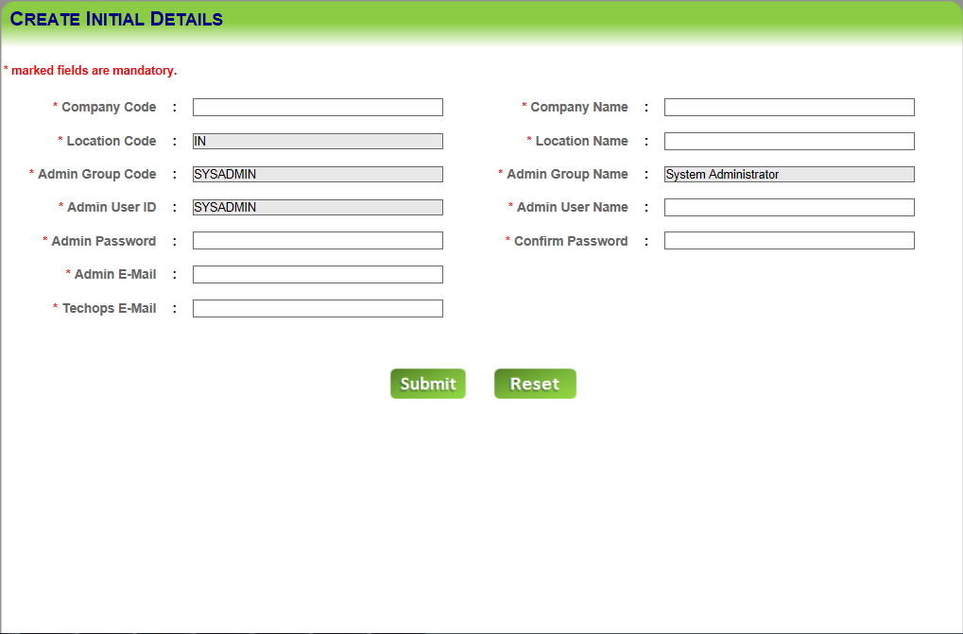

Here user enters the values of “Company Code (2 characters only), Location Code (2 characters only), Admin Group Code, Admin User ID, Admin Password, Admin E-Mail, Manager E-Mail, Company Name, Location Name, Admin Group Name, Admin User Name, Confirm Password” in the respective textboxes. After filling all the data, when user clicks on “submit” button, the details saved successfully message is displayed. User can also clear the fields’ data by clicking on “Reset” button after filling all the data.

### Category Master

**Masters 🡪 Category Master:** The screen below is used to create, edit, delete & view asset category details.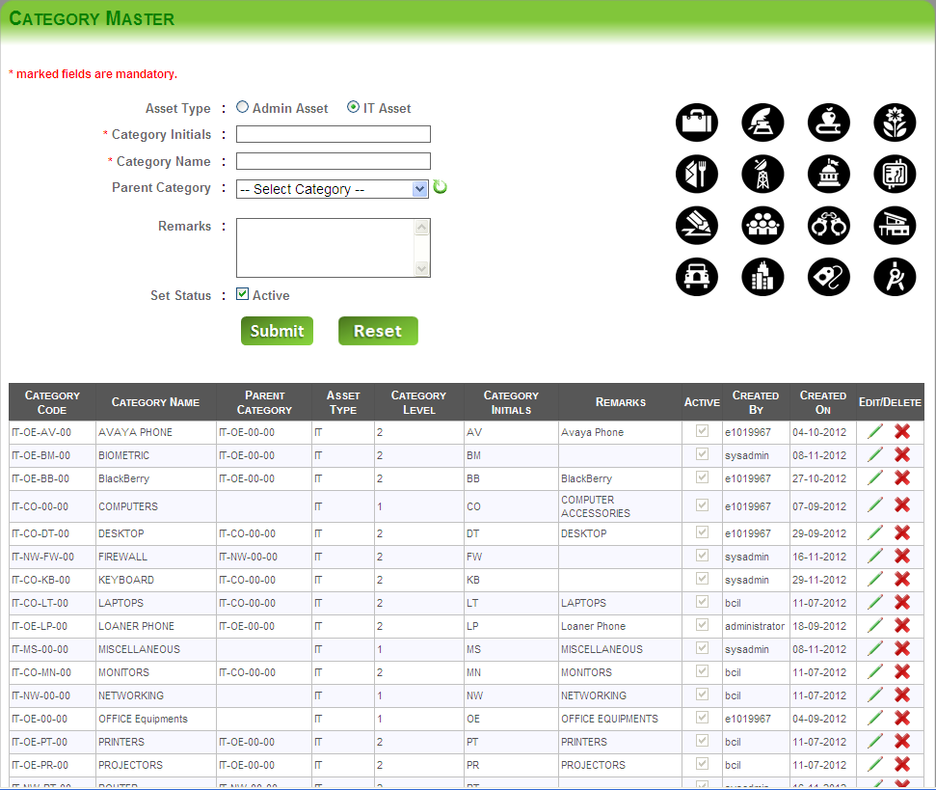

Here, the user can select the “Asset Type” through radio buttons, enters the values of “category Initials, category name” in the respective textboxes. User can also select the “**parent category”** (if category needs to be created as child category) from the drop down. User can also enter “**remarks”** about the category in the text area. The **“status”** of the category is set **active** by checking the check box. Categories can only be created up to 3 levels (Parent 🡪 child 🡪 sub child). On clicking the **“Submit”** button, the category will be created and displayed in the grid. User can also clear the fields’ data by clicking on “Reset” button. Category once created would be applicable for all assets at all locations. Each location users need not to create their own categories. Category Initials are critical and must remain unique for a category. User can “edit and delete” category details by clicking on “edit” and “delete” buttons respectively provided on the grid. User can also export the category details into an excel file by clicking on “Export” button.

D:\Neeraj_Projects\Running_Projects\DAIMLER_ATS\DAIMLER_ATS\MobiVUE_ATS\images\Excel-icon (2).png 🡪 This image should be considered as icon for export data into excel file wherever in ATS.

### Company Master

**Masters 🡪 Company Master:** The screen is used to create, edit, delete & view company details.

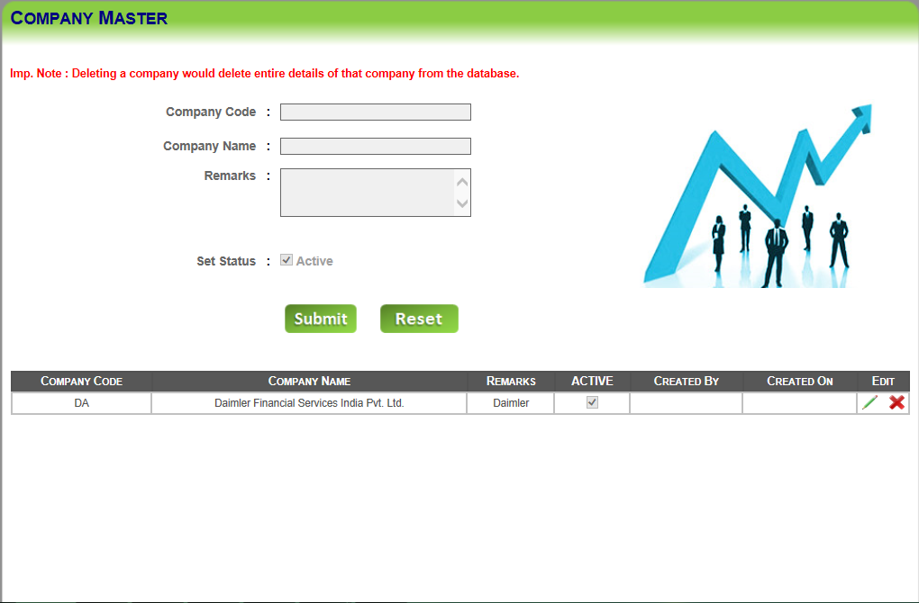

Here User can enter the values of **“company code, Company name”** in the respective textboxes. User can also enter “**remarks”** about the company in the text area. The “**status”** of the company is set **active** by checking the check box. Creating company name is one time activity for each location.

On clicking **“Submit”** button, the company details will be created and displayed in the grid view. User can clear/reset fields’ data by clicking on “Reset” button. User can “edit/update/delete” company details through edit/delete buttons provided on the grid.

**Note: “SYSADMIN” group user must be very careful while granting delete rights to the end user. The user must be very careful while deleting company details through “Company Master”, since deleting a company would delete entire details of that company from the database.**

### Department Master

**Masters 🡪 Department Master:** The screen is used to create, edit, delete & view department details.

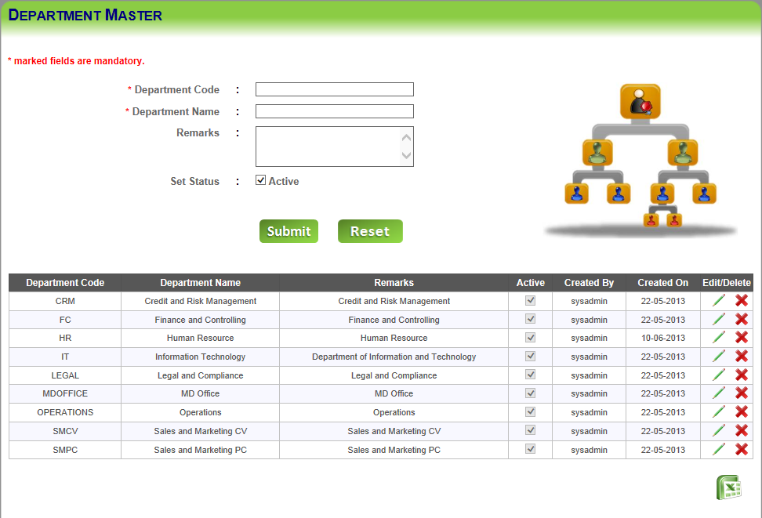

Here, the user can enter the values of **“Department code, Department name”** in the respective fields. User can also enter “**remarks”** about the department in the respective text area. The “**status”** of the department is set **active** by checking the check box.

On clicking the **“Submit”** button, the department details will be created and displayed in the below grid view. Department details can be edited or deleted through edit/delete buttons provided on the grid. The user can also clear the fields’ data through “Reset” button.

User can also export the department master details into an excel file by clicking on “Export” button.

### Employee Master

**Masters 🡪 Employee Master:** The screen is used to create, edit, delete & view employee details.

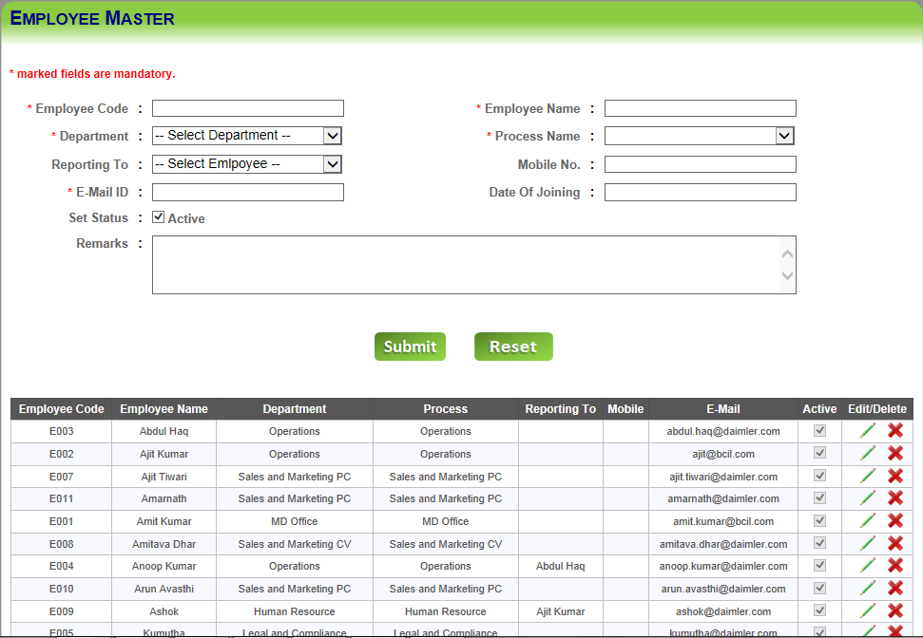

Here User can enter the values of **“Employee code/id, Employee name, Email id, Date of Joining and mobile No.”** in the respective textboxes. One can select the process name and reporting to employee name from the respective dropdowns. User can also enter “**remarks”** about the employee in the text area. The “**status”** of the employee is set **active** by checking the check box. On clicking the **“Submit”** button, the employee details will be created and displayed in the below grid view. User can also clear the fields’ data by clicking on “Reset” button. User can edit and delete Employee details through edit and delete buttons respectively provided on the grid. Employee master details can be exported into an excel file through “Export” button.

### Group Master

**Masters 🡪 Group Master:** The screen is used to create, edit, delete & view group master details.

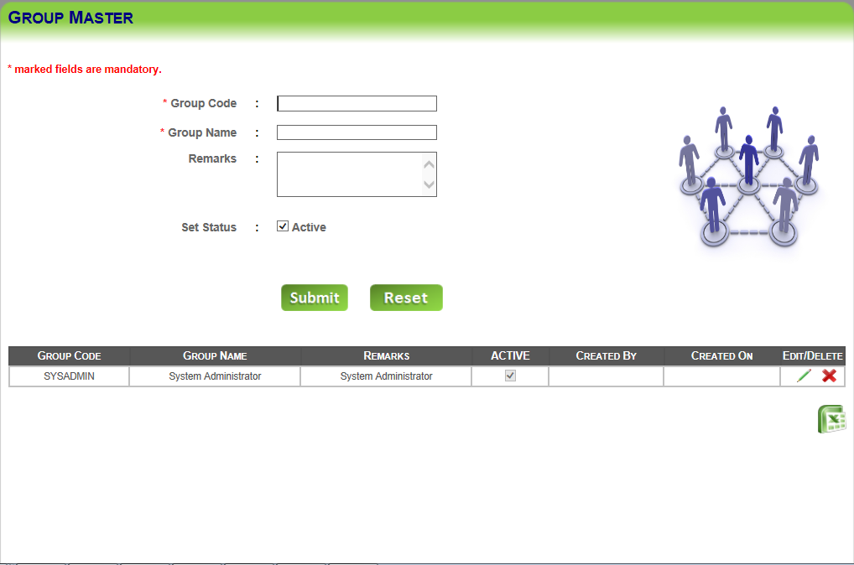

Here User can enter the values of **“Group code, Group name”** in the respective textboxes. User can also enter “**remarks”** about the group master in the text area. The “**status”** of the group is set **active** by checking the check box.

On clicking the **“Submit”** button, the group details will be created and displayed in the below grid view. User can edit/update and delete group details through edit and delete buttons respectively provided on the grid. User can also clear/reset fields’ data by clicking on “Reset” button.

User can also export the (grid details) into an excel file by clicking on “Export” button.

### Group Rights

**Masters 🡪 Group Rights:** The screen below is used to grant/revoke group rights to the groups created through **Group Master**.

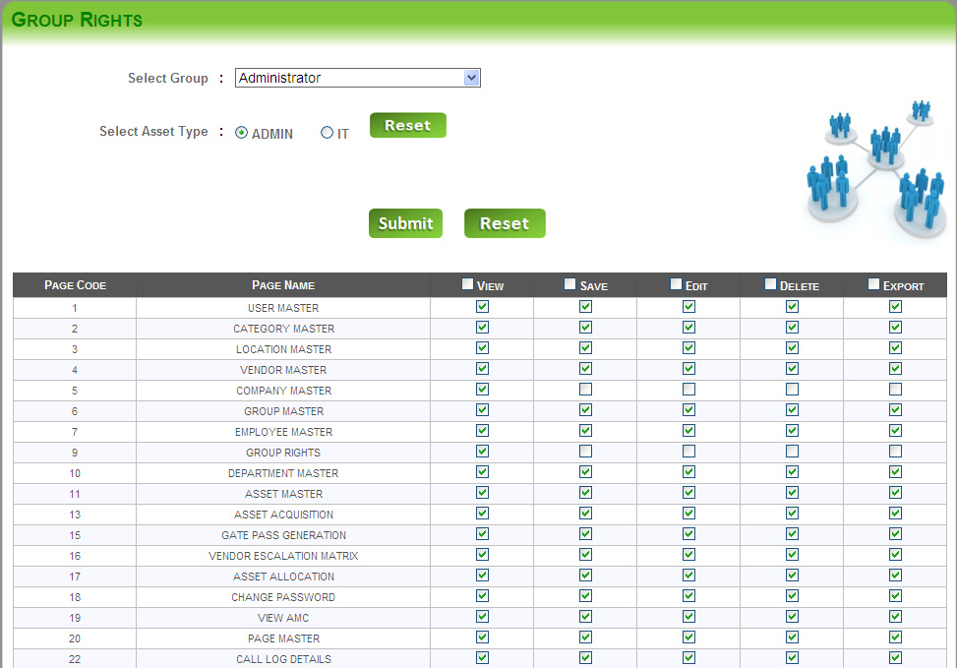

Here, the user selects the **“group”** from the drop down and selects **“Asset Type”** through radio buttons in order to grant/revoke group rights.

On clicking the **“Submit”** button, the group rights will be saved/updated, which were selected through the grid. For each and every page of the entire application, rights can be granted/revoked for all groups in that particular location of the company.

User can also export group rights details into an excel file by clicking on “Export” button.

**Note: “SYSADMIN” group rights cannot be edited but “SYSADMIN” group user himself/herself can change other users' group rights. Only “SYSADMIN” group user can have Group Rights page view/save/edit/delete/export rights (view page code # 9 in the above screen shot).**

### Location Master

**Masters 🡪 Location Master:** The screen below is used to create, edit, delete & view location master details.

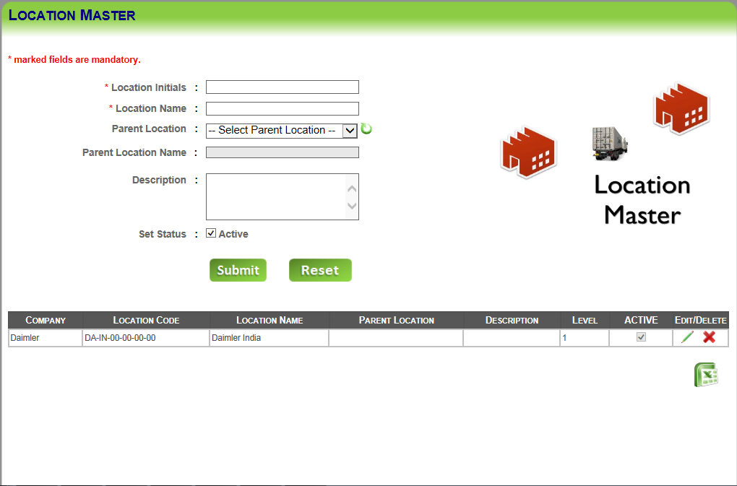

Here User enters the values of **“location Initials, location name**” in the respective textboxes. User can also select the **“parent location”** (if exists) from the drop down. User can also enter a “**description”** about the location in the text area. The **“status”** of the location is set **active** by checking the check box. Locations can be created up to **5 levels** (parent as level 1 and last sub child as level 5)only.

On clicking the **“Submit”** button, the location will be created and displayed in the below grid view. User can also clear/reset fields’ data by clicking on “Reset” button. User can edit/update and delete location master details through edit and delete buttons respectively provided on the grid. User can also export location master details into an excel file by clicking on “Export” button.

### Process Master

**Masters 🡪 Process Master:** This screen is used to create, edit, delete & view process master details.

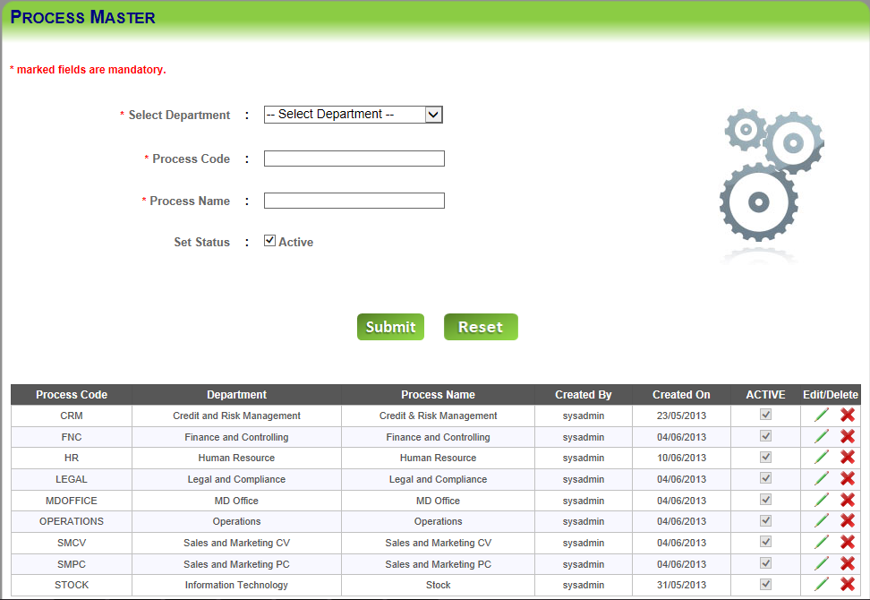

Here User selects the **“Department Type”** from the drop down, enter the values of **“process code, process name**” in the respective textboxes. The **“status”** of the process is set **active** by checking the “**Set Status**” check box. On clicking the **“Submit”** button, the process will be created and displayed in the below grid view. User can also clear the fields’ data by clicking on “Reset” button after filling all the data. User can edit and delete process master details through edit and delete buttons respectively provided on the grid. User can export process master details into an excel file by clicking on “Export Button”.

### User Master

**Masters 🡪 User Master:** The screen below is used to create, edit, delete & view user master details.

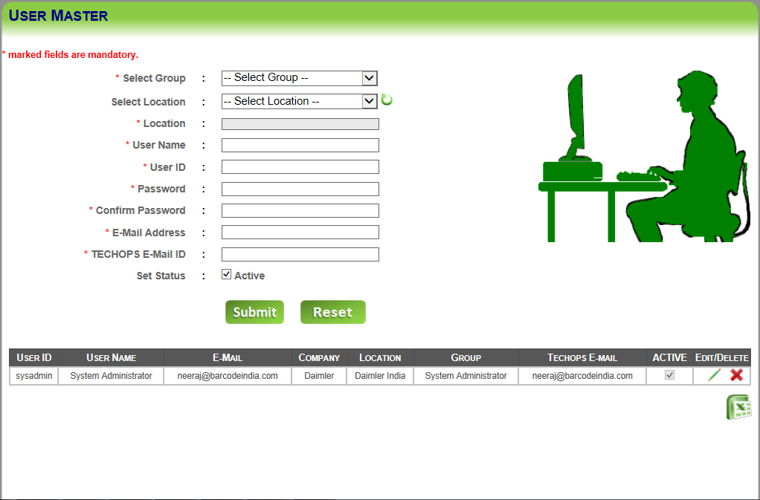

Here user selects g**roup** and **location** from the respective dropdowns, enter the values of **“User name, User ID, password, confirm password, E-mail Address, TECHOPS E-Mail ID”** in the respective textboxes to create a user in a location. The “**status”** of the user is set **active** by checking the check box.

Through **“Submit”** button, the user details will be created and displayed in the grid view. User can also clear/reset fields by clicking on “Reset” button.

User can “edit and delete” grid information through edit and delete buttons respectively provided on the grid.

Note: While editing the grid information “SYSADMIN” group user can never change its own group but can change other user’s group whereas other user can never change own/other user’s group.

User can also export user master details into an excel file by clicking on “Export Button”.

### Vendor Master

**Masters 🡪 Vendor Master:** The screen below is used to create, edit, delete & view vendor master details.

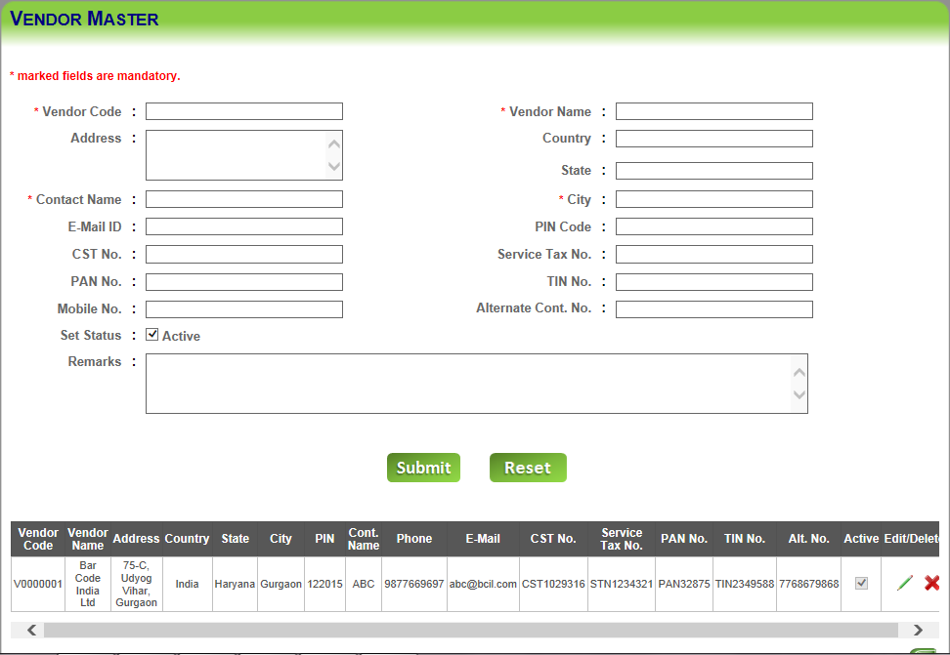

Here user enters the values of **“vendor code, vendor name, address, contact name, e-mail ID, phone no., country, state, city and pin code etc.”** in the respective textboxes. User can also enter “**remarks”** about the vendor in the text area. The “**status”** of the vendor is set **active** by checking the check box.

On clicking the **“Submit”** button, the vendor details will be created and displayed in the grid view. User can also clear/reset fields’ data by clicking on “Reset” button. User can “edit and delete” grid information through edit and delete buttons respectively provided on the grid. User can export vendor master details into an excel file by clicking on “Export” button.

## Asset

The Asset tab contains following pages/links:

* Import/Export Data
* Asset Acquisition
* Approve Assets
* Asset Allocation
* Asset Replacement
* Asset Transfer
* Generate Gate Pass
* Sold – Scrapped
* Swapping Assets

### Import/Export Data

**Asset 🡪 Import/Export Data:** The screen below is used for importing and exporting data.

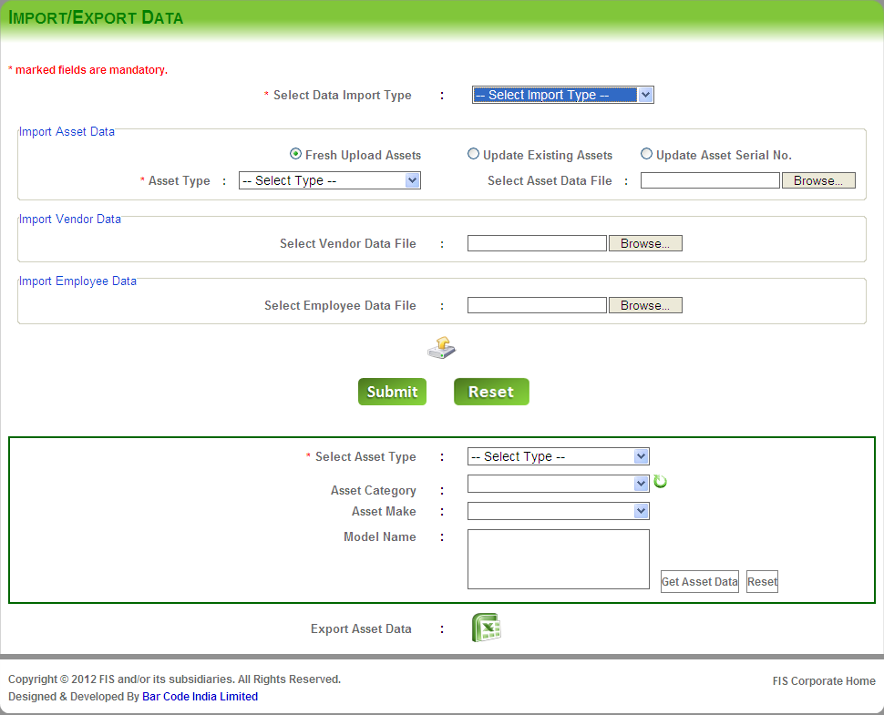

To Import (saving data into the database) the data, user will select the **“data import type”** from the dropdown. To save fresh asset details, select **“Fresh Upload Assets”** radio button. For existing assets’ details update, select **“Update Existing Assets”** radio button. For update of Serial Nos. of assets, select **“Update Asset Serial No.**” radio button. User selects the “**asset type**” from the drop down, browse the “asset data file” from the computer to import/save. User browse the “**vendor data file** and **employee data file**” to import vendor data and employee data file respectively.

On clicking the “Upload” button, all the selected files will get uploaded at local machine.

On clicking the **“Submit”** buttonthe entered data will be saved or updated. User can also reset fields’ data by clicking on “Reset” button.

To export the data, user can select asset type, category, asset make and model name/no. in order to filter assets. Through “Get Assets Data” button, asset data can be fetched. Clicking on the excel button, filtered data will be exported. For bulk upload of assets, the format of the excel file should following format. (All the columns in yellow background are mandatory)

|  |  |  |  |
| --- | --- | --- | --- |
| **COLUMN NAME** | **DATA TYPE** | **VALID VALUES** | **INVALID VALUES** |
| FAMSID | Text |  |  |
| SerialCode | Text |  |  |
| CategoryCode | Text | Should be created prior through **Category Master** | Any non-existing **Category Code** in **Category Master** |
| LocationCode | Text | Should be created prior through **Location Master** | Any non-existing **Location Code** in **Location Master** |
| AMC\_Warranty | Text | AMC/WARRANTY/NONE | Must not be blank |
| AMC\_Wrnty\_Start\_Date | Date | 09/15/2012 | 15/09/2012 |
| AMC\_Wrnty\_End\_Date | Date | 09/15/2012 | 15/09/2012 |
| VendorCode | Text | Should be created prior through **Vendor Master** | Any non-existing **Vendor Code** in **Vendor Master** |
| AssetInstallDate | Date | 09/15/2012 | 15/09/2012 |
| PurchasedDate | Date | 12/31/2012 | 31/12/2012 |
| AssetPurchaseValue | Numeric | 123456.78  12345.67  12345.68 | 123,456.78  123,23.67  12345.678 |
| PurchaseOrderNo | Text |  |  |
| PODate | Date | 09/15/2012 | 15/09/2012 |
| InvoiceNo | Text |  |  |
| AssetSaleDate | Date | 09/15/2012 | 15/09/2012 |
| AssetSaleValue | Numeric | 123456.78  12345.67  12345.68 | 123,456.78  123,23.67  12345.678 |
| AssetMakeName | Text |  |  |
| AssetModelName | Text |  |  |
| ProcessCode | Text | Should be created prior through **Process Master** | Any non-existing **Process Code** in **Process Master** |
| SecurityClassification | Text |  |  |
| AssetSize | Text |  |  |
| AssetVlan | Text |  |  |
| AssetHDD | Text |  |  |
| AssetProcessor | Text |  |  |
| AssetRAM | Text |  |  |
| AssetIMEINo | Text |  |  |
| AssetPhoneMemory | Text |  |  |
| ServiceProvider | Text |  |  |
| AssetType | Text | ADMIN/IT | Must not be blank |
| \*AssetBOE | Text |  |  |
| BondRegisterNo | Text |  |  |
| BondedType | Text | CBD/NCBD | Any value other than left hand side value |
| CapitalisedType | Text | CAP/NCAP | Any value other than left hand side value |
| VerifiableType | Text | VER/NVER | Any value other than left hand side value |
| PortNo | Text |  |  |
| WorkstationNo | Text |  |  |
| CostCenterNo | Text |  |  |
| SecurityGENo | Text |  |  |
| SecurityGEDate | Date | 09/15/2012 | 15/09/2012 |
| CompanyCode | Text | Should be created prior through **Company Master** | Any non-existing **Company** **Code** in **Company Master** |
| CompanyName | Text | Should be created prior through **Company Master** | Any non-existing **Company** **Name** in **Company Master** |
| CustomerOrderNo | Text |  |  |
| DepartmentCode | Text | Should be created prior through **Department Master** | Any non-existing **Department Code** in **Department Master** |

\*Asset BOE No. is **mandatory** only when **asset bonded type** is selected as **custom-bonded type (CBD)**. For non custom-bonded asset type, Asset BOE No. should be kept as empty.

For bulk update of assets, excel file format is as below:

|  |  |  |  |
| --- | --- | --- | --- |
| **COLUMN NAME** | **DATA TYPE** | **VALID VALUES** | **INVALID VALUES** |
| Asset\_Code | Text | Application generated Asset Code | Any non-existing A**sset Code** in **Asset Acquisition** |
| FAMSID | Text |  |  |
| SerialCode | Text |  |  |
| CategoryCode | Text | Should be created prior through **Category Master** | Any non-existing **Category Code** in **Category Master** |
| LocationCode | Text | Should be created prior through **Location Master** | Any non-existing **Location Code** in **Location Master** |
| AMC\_Warranty | Text | AMC/WARRANTY/NONE | Must not be blank |
| AMC\_Wrnty\_Start\_Date | Date | 09/15/2012 | 15/09/2012 |
| AMC\_Wrnty\_End\_Date | Date | 09/15/2012 | 15/09/2012 |
| VendorCode | Text | Should be created prior through **Vendor Master** | Any non-existing **Vendor Code** in **Vendor Master** |
| AssetInstallDate | Date | 09/15/2012 | 15/09/2012 |
| PurchasedDate | Date | 12/31/2012 | 31/12/2012 |
| AssetPurchaseValue | Numeric | 123456.78  12345.67  12345.68 | 123,456.78  123,23.67  12345.678 |
| PurchaseOrderNo | Text |  |  |
| PODate | Date | 09/15/2012 | 15/09/2012 |
| InvoiceNo | Text |  |  |
| AssetSaleDate | Date | 09/15/2012 | 15/09/2012 |
| AssetSaleValue | Numeric | 123456.78  12345.67  12345.68 | 123,456.78  123,23.67  12345.678 |
| AssetMakeName | Text |  |  |
| AssetModelName | Text |  |  |
| ProcessCode | Text | Should be created prior through **Process Master** | Any non-existing **Process Code** in **Process Master** |
| SecurityClassification | Text |  |  |
| AssetSize | Text |  |  |
| AssetVlan | Text |  |  |
| AssetHDD | Text |  |  |
| AssetProcessor | Text |  |  |
| AssetRAM | Text |  |  |
| AssetIMEINo | Text |  |  |
| AssetPhoneMemory | Text |  |  |
| ServiceProvider | Text |  |  |
| AssetType | Text | ADMIN/IT | Cannot be blank |
| \*AssetBOE | Text |  |  |
| BondRegisterNo | Text |  |  |
| BondedType | Text | CBD/NCBD | Any value other than left hand side value |
| CapitalisedType | Text | CAP/NCAP | Any value other than left hand side value |
| VerifiableType | Text | VER/NVER | Any value other than left hand side value |
| PortNo | Text |  |  |
| WorkstationNo | Text |  |  |
| CostCenterNo | Text |  |  |
| SecurityGENo | Text |  |  |
| SecurityGEDate | Date | 09/15/2012 | 15/09/2012 |
| CompanyCode | Text | Should be created prior through **Company Master** | Any non-existing **Company** **Code** in **Company Master** |
| CompanyName | Text | Should be created prior through **Company Master** | Any non-existing **Company** **Name** in **Company Master** |
| CustomerOrderNo | Text |  |  |
| DepartmentCode | Text | Should be created prior through **Department Master** | Any non-existing **Department Code** in **Department Master** |

In order to update asset serial no. in bulk mode, the excel file format is as below.

|  |  |  |  |
| --- | --- | --- | --- |
| Asset Code | Existing Serial No. | New Serial No. | Company Code |

For Vendor Details upload, the excel file format is as below.

|  |  |  |  |
| --- | --- | --- | --- |
| **COLUMN NAME** | **DATA TYPE** | **VALID VALUES** | **INVALID VALUES** |
| VendorCode | Text |  | Cannot be blank |
| VendorName | Text |  | Cannot be blank |
| VendorAddress | Text |  |  |
| VendorCountry | Text |  |  |
| VendorSate | Text |  |  |
| VendorCity | Text |  | Cannot be blank |
| VendorPIN | Text |  |  |
| VendorContPerson | Text |  | Cannot be blank |
| VendorPhone | Numeric |  |  |
| VendorEmail | Text |  | Text which is not in email format |
| CST No. | Text |  |  |
| Service Tax No. | Text |  |  |
| PAN No. |  |  |  |
| TIN No. |  |  |  |
| Alternate Contact No. | Numeric |  |  |

In order to upload employee details in bulk, the excel file format is as below:

|  |  |  |  |
| --- | --- | --- | --- |
| **COLUMN NAME** | **DATA TYPE** | **VALID VALUES** | **INVALID VALUES** |
| Employee Code | Text |  | Cannot be blank |
| Employee Name | Text |  | Cannot be blank |
| Employee Company Code | Text |  | Cannot be blank |
| Employee Dept. Code | Text | Should be created prior through **Department Master** | Cannot be blank |
| Employee Process Code | Text | Should be created prior through **Process Master** | Cannot be blank |
| Employee Reporting To | Text | Employee ID |  |
| Employee Email | Text |  | Cannot be blank |
| Employee Date Of Joining | Text |  |  |
| Employee Mobile No. | Text |  |  |

Note: In order to import asset data (ADMIN/IT), excel file format is already shared with the concerned persons at all locations. It is very critical that the excel file format should be strictly followed.

### Asset Acquisition

**Asset 🡪 Asset Acquisition:** The screen below is for **Asset Acquisition** (acquiring new assets) utility. User enters the details of the assets in order to save/update asset details.

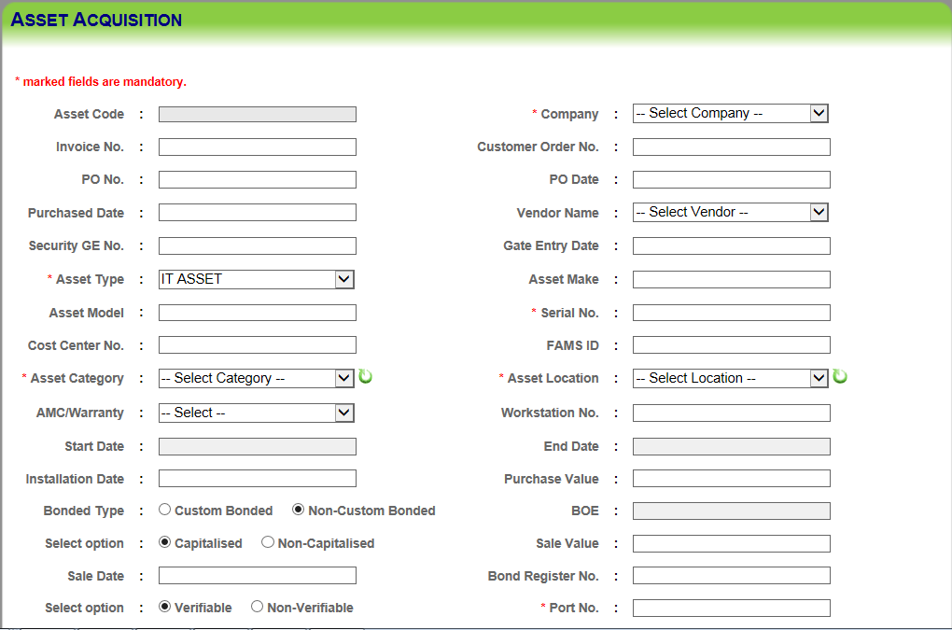

Here, the user enters/selects asset details (ADMIN/IT) in the respective textboxes/dropdowns. In case the asset is **custom-bonded**, Asset **BOE No.** is mandatory to be entered in the respective textbox. User can also select the values of “Bonded Type, Options” through radio buttons. If the user selects **AMC or Warranty** through **AMC/Warranty dropdown**, **Start Date** and **End Date** are mandatory to be entered. In case of IT assets, few more fields are visible below in the screen in order to fill details such as HDD, RAM, Size, Blackberry phone details, IMEI no. etc.

On clicking “**Submit”** button, the asset acquisition details will be saved or updated. User can also clear the fields’ data by clicking on “Reset” button.

### Approve Assets

**Asset 🡪 Approve Assets:** The screen below is for approving newly acquired/updated assets. User can get the list of acquired assets through provided filters and then approve assets in bulk through the submit button, given below the unapproved assets list.

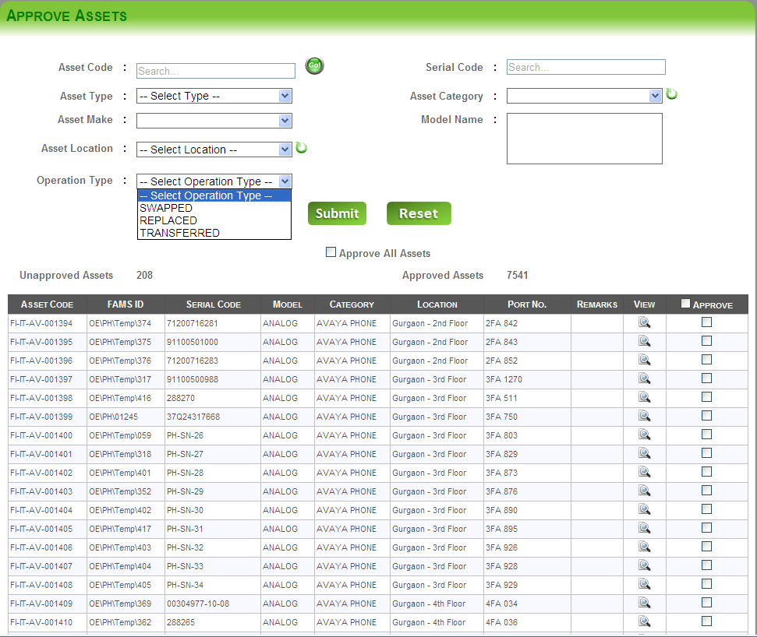

Here, the user gets asset details (ADMIN/IT) by searching through asset type, category, make and model type. User can also search the asset by providing either **asset code or serial code**.

The count of unapproved assets and approved assets are displayed as per search criteria provided. On clicking “**Submit”**, the asset details will appear in the grid below. Assets for approval can be obtained by selecting **“Operation Type”** through dropdown such as **SWAPPED/REPLACED/TRANSFERRED**. Selecting the approve checkboxes (provided on the grid) and after submitting, all the selected assets will get approved. User can also clear/reset fields’ through Reset button in order to start a fresh search. The user can approve all assets in one go by checking “Approve All Assets” checkbox and click on “Submit” button below data grid.

### Asset Allocation

**Asset 🡪 Asset Allocation:** Allocation of the assets is done trough the screen given below. User enters mandatory details and gets a list of assets though “From Process” dropdown. On clicking **Get Assets** button, a list of assets appears as per search criteria provided.

**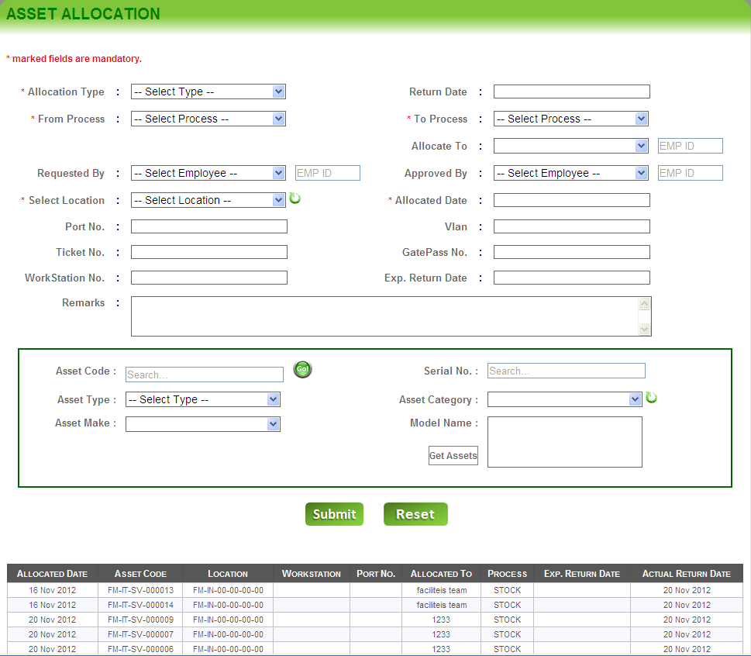**

By selecting assets through checkboxes given on the assets list, assets are allocated to a process through the screen displayed above. User can also search the asset by providing either “**asset code”** or **“serial code”**. Allocated assets can be re-allocated/returned to/from employees/processes though the asset allocation screen also.

User can also clear/reset the fields’ data by clicking on “Reset” button in order to start a fresh search and fresh allocation.

### Asset Replacement

**Asset 🡪 Asset Replacement:** When a new asset is replaced with the faulty one, new serial no. against the asset code (since asset code remains unchanged even when the asset is replaced) is to be saved. Enter **asset code** of the asset in the respective textbox and press “**Go”** button to get details of the asset displayed on the form. Enter new serial no. of the replaced asset in **Asset Serial No.** textbox.

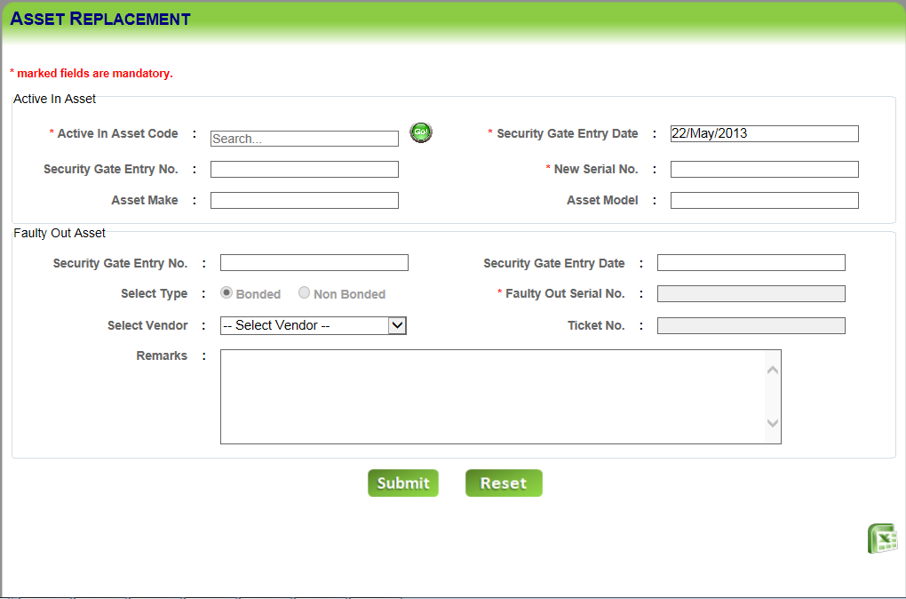

On clicking the “**Submit”** button, the replacement details would be saved in asset replacement history and asset details are updated. User can also clear the fields’ data by clicking on “Reset” button. Asset replacement history details can be exported into excel file by clicking on “Export” button.

### Asset Transfer

**Asset 🡪 Asset Transfer:** Assets aretransferred from one location to another within a building or from one city location to another city location. In order to transfer assets, details are entered in the respective textboxes, and through “Submit” button details are saved. All types of transferred assets history details are displayed on the same page. Transferred history details can also be exported into an excel file through export button. The assets which are transferred to another city can be exported and sent to the city where the assets are being transferred. Once successful upload of the assets at that location and confirmation, assets need to be deleted from the location from where the assets were transferred.

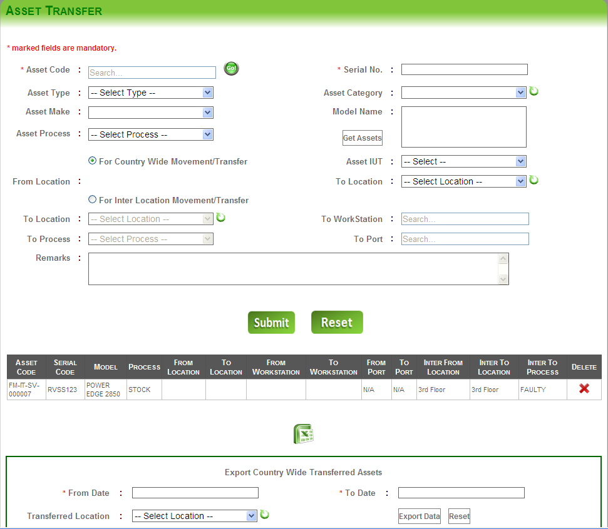

User can also clear/reset the fields’ data by clicking on “Reset” button in order to start a fresh search. User can also export the asset transfer details into an excel file by clicking on “Export” button.

NOTE: To export the details of the assets which were transferred country wise, user selects the “details” from the respective textboxes/drop down. On clicking the “Export” button, transferred assets will be exported into excel file.

### Gate Pass Generation

**Asset 🡪 Gate Pass Generation:** Gate passes are generated in order to transfer/move assets from one location to another. Gate pass details are entered in the respective textboxes and the asset list can be viewed through “**Get Assets”** button. Assets are selected through the assets list and gate pass can be generated by clicking on submit button.

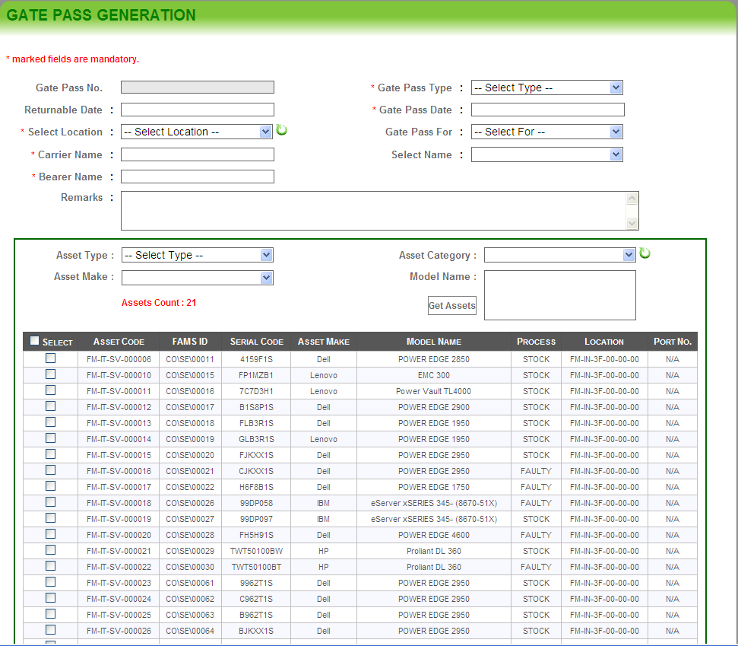

On clicking “**Submit”**, the gate pass details will appear in the grid. User can print the gate pass on clicking the gate pass link. User can also clear the fields’ data by clicking on “Reset” button.

### Sold/Scrapped Assets:

**Asset 🡪 Sold/Scrapped Assets:** The screen below is for dumping the assets. User enters the details of the asset which needs to be scrapped and assets then press “Submit” button to save the details of scrapped or sold assets.

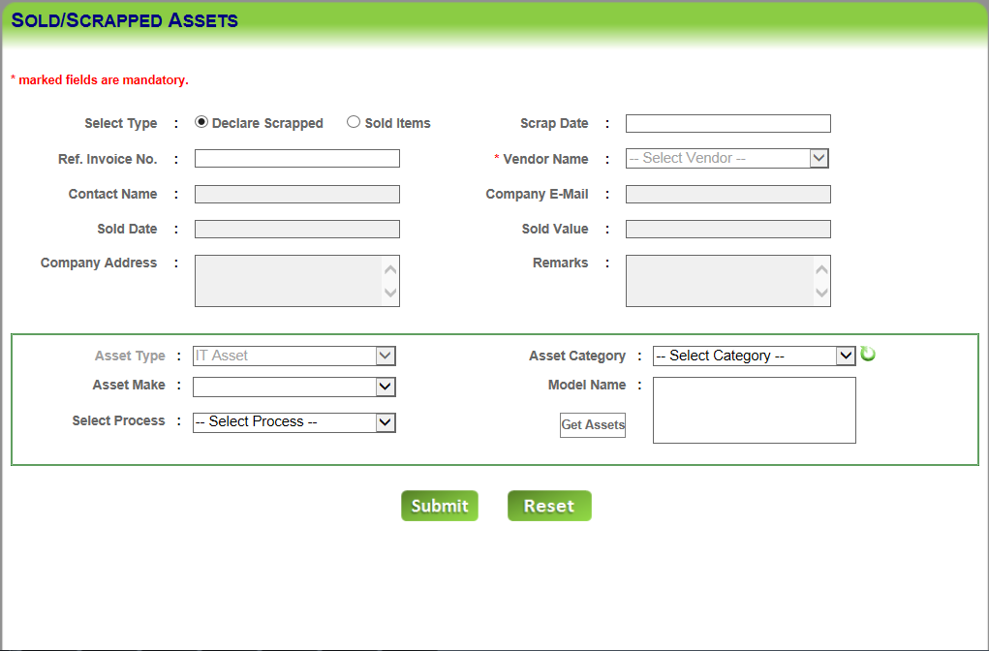

Here, user can declare the asset as scrap and then can sell it. Assets declared as scrapped, will be appeared, when being sold. User enters/selects **scrapped asset details** (ADMIN/IT) in the respective textboxes /dropdowns. User can get the asset details by clicking on “**Get Assets**”. On clicking “**Submit”**, the details of the scrapped material will appear in the grid below. User can delete the scrapped/sold assets from the grid. User can also clear the fields’ data by clicking on “Reset” button. User can also export the (grid details) into an excel file by clicking on “Export” button.

### Swap Assets

**Asset 🡪 Swap Assets:** This screen is for swapping the asset from one location/employee/process to another location/employee/process within a physical location. User enters the details of the asset which needs to be scrapped and assets then press “**Submit**” button to swap the selected assets.

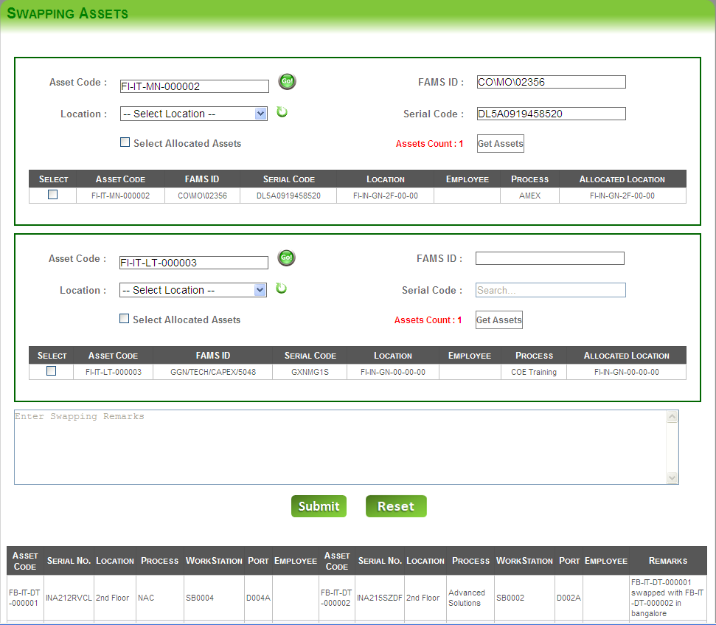

Here the user gets the asset details for “**from**” and “**to**” locations by clicking on “**Get Assets**” buttons. The details of the assets of “from” and “to” locations will appear in the grid below. User can select the asset from both the grids to swap.

**Note: At a time only two items can be swapped with each other and user can’t select the similar assets to swap.**

User can reset/clear fields’ data by clicking on the “Reset” button.

## Support

The Support tab contains following pages:

1. Asset Re-Conciliation
2. View Asset List
3. View AMC List
4. View Gate pass List
5. Vendor Call Log Management
6. Vendor Escalation Matrix

### Asset Reconciliation

**Support 🡪 Asset Reconciliation:** The screen below is for reconciling the scanned (barcode) assets. 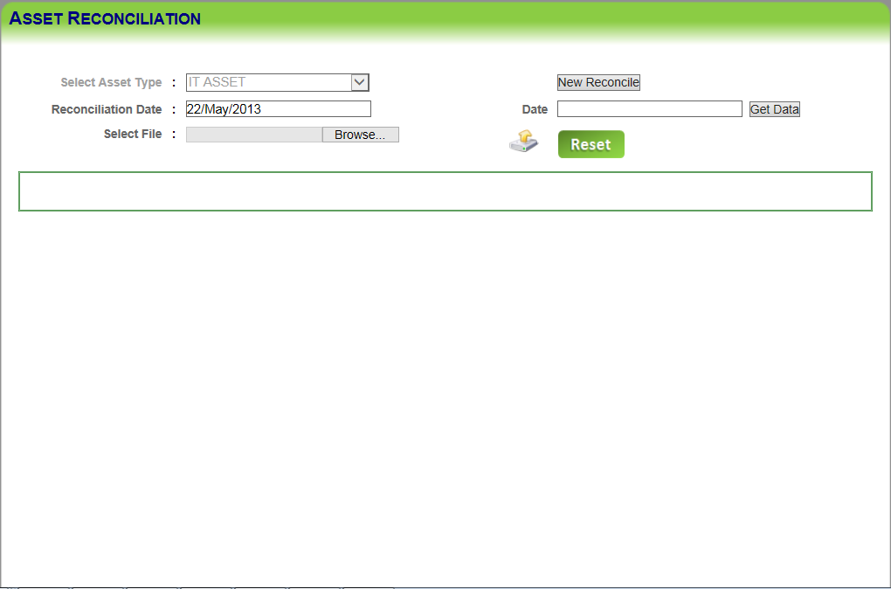

Here the scanned asset barcodes files can be downloaded from the scanner device. Then through the software, assets are reconciled in order to cross check assets location/process details. Valid asset barcodes are displayed on top left of the screen, once reconciliation is carried out. Invalid assets details are displayed on the right side of the screen. All the other asset’s details are displayed just below the above said two details. The below grid describes whether the assets are scanned or not. Those assets, which are not scanned yet displayed as well.

### View Asset List

**Support 🡪 View Asset List:** This screen is for viewing the asset list.

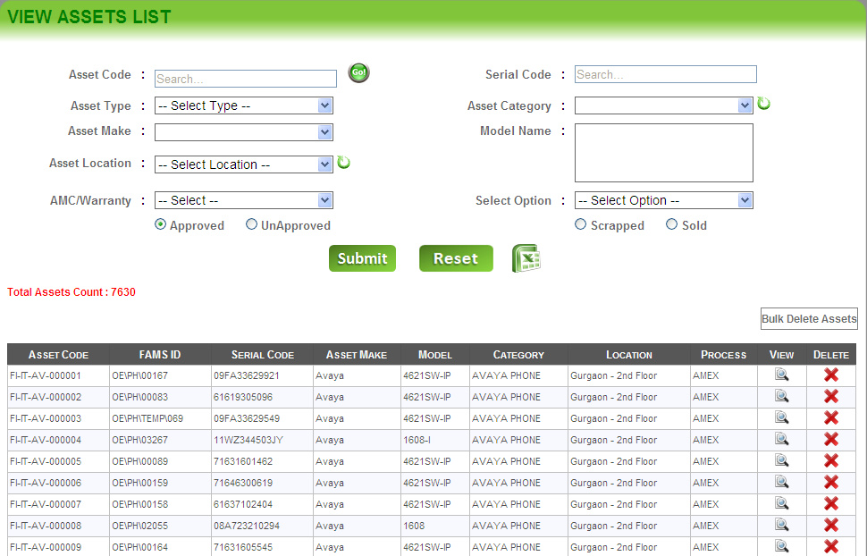

Here assets list can be viewed. User can get a list of assets based on filters like “**Asset Code, Serial Code, Asset Type, Category, Make, Model, Location, AMC/Warranty, Approved/Unapproved, and Verifiable/Non-Verifiable etc**.” User can view each and every asset details through view button given in the grid. Assets can be deleted single in once or in bulk as given on the screen above. Assets list can be exported into excel sheet also. Clicking on view button (provided on grid), asset details can be viewed in edit/update mode on “**Asset Acquisition”** page. Assets’ details can be updated from there.

Assets can be deleted one at a time or in bulk mode as per the need.

**Only “SYSADMIN” group user can change/update asset serial no. while editing/updating asset details. Asset category cannot be changed while updating asset’s details.**

### View Asset AMC

**Support 🡪 View Asset AMC:** The screen below is for viewing the assets’ AMC list.

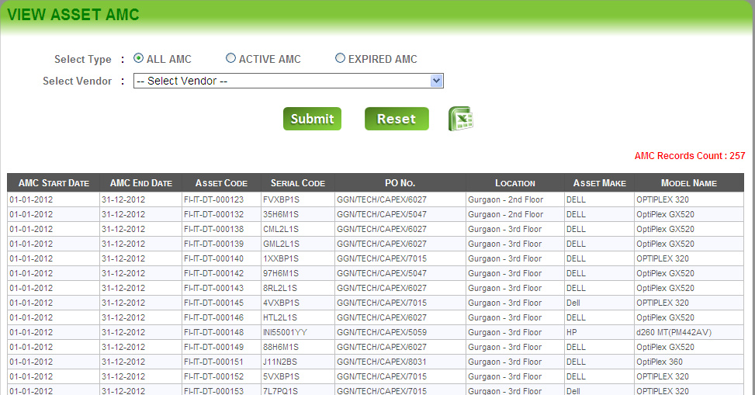

Here User can get the list assets AMC based on filters like **type** and **vendor**. Expired/about to expire AMC’s can also be viewed through the screen when **“EXPIRED AMC”** radio button is selected. All AMC details can be viewed when **“ALL AMC”** radio button is selected. Only active AMC’s can be viewed when **“ACTIVE AMC”** radio button is selected.

On clicking “**Submit”**, the details of the AMC list will appear in the grid below. User can reset/clear fields’ data by clicking on “Reset” button.

User can also export assets’ AMC details into an excel file by clicking on “Export” button.

### View Gate pass List

**Support 🡪 View Gate Pass List:** This screen is to view the list of gate passes.

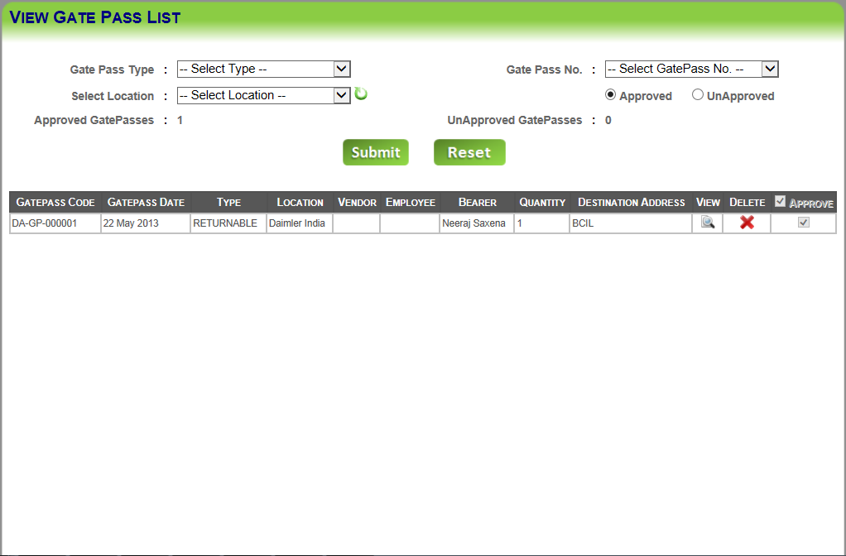

Here User can get the list of gate passes generated based on filters like “**gate pass type, gate pass no., location, approved/unapproved**”. User can view each and every gate pass details through view button given in the grid, on clicking on it user will be directed to the **Gate Pass Generation** page and can view all the details. Gate passes can be deleted through the delete button provided on the grid.

On clicking **“Submit”**, the details of the generated gate passes will appear in the grid below. User can reset/clear fields’ data by clicking on “Reset” button.

### Vendor call log management

**Support 🡪 Vendor Call Log Management:** This screen is to view the call log details of the vendors.

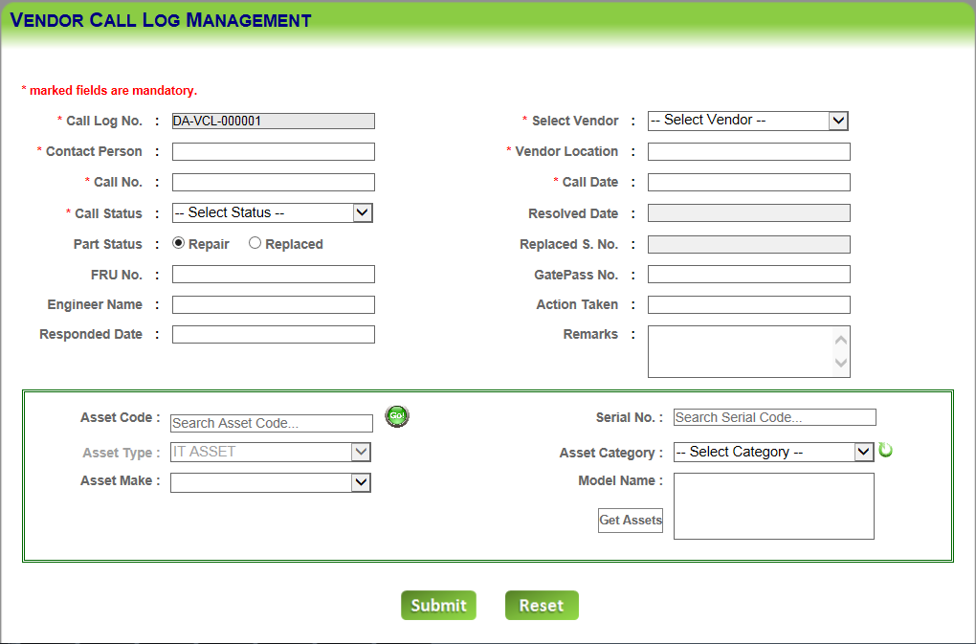

Here the user gets the asset details to which vendor call has to be assigned by clicking on “**Get Assets**” buttons. User then enters the details like “**call Log no., contact person, vendor, vendor location, etc.**” in the respective textboxes/dropdowns. By selecting the asset from the grid below and filling the details, user will click on “**Submit”** button to submit the details. User can view all the submitted details by clicking on view button given in the grid. User can also change its call status (i.e. if it’s **pending**, it can be changed to **resolved** or **unresolved**). User can reset/clear fields’ data by clicking on “Reset” button.

### Vendor Escalation Matrix

**Support 🡪 Vendor Escalation Matrix:** This screen is to save/update/delete vendor escalation matrix details.

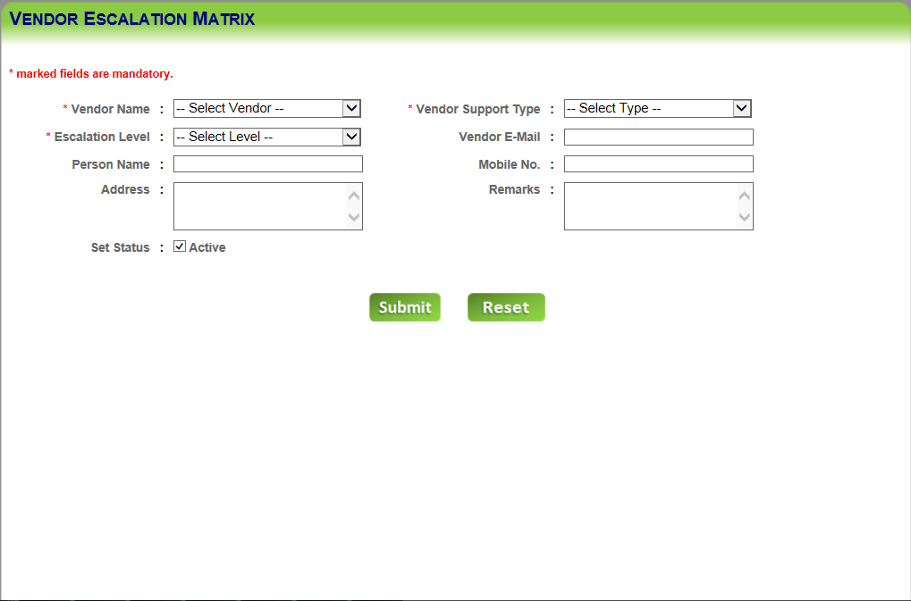

Here User can enter the values of **“vendor name, escalation level, person name, vendor support type, vendor email, person name, mobile no., address”** in the respective textboxes/dropdowns. User can also enter “**remarks”** about the vendor escalation in the text area. The “**status”** of the employee is set **active** by checking the **“Set Status”** check box. On clicking the **“Submit”** button, the vendor escalation details will be submitted and displayed in the below grid view. User can “edit” and “delete” grid information by clicking on edits and delete buttons respectively. User can reset/clear fields’ data by clicking on “Reset” button.

## Reports

The report tab contains following reports:

* Allocation Report
* In-Stock Report
* Tracking Report
* Summary Report
* History Report
* Dashboard Report
* Call – Log Report
* Allocated Returnable
* Gate Pass Report
* Returnable Assets

### Asset Allocation Report

**Report 🡪 Asset Allocation Report:** This screen is to view the asset allocation report. Through this page, asset allocation dashboard (in chart and cross tab format) and single asset allocation distribution can also be viewed.

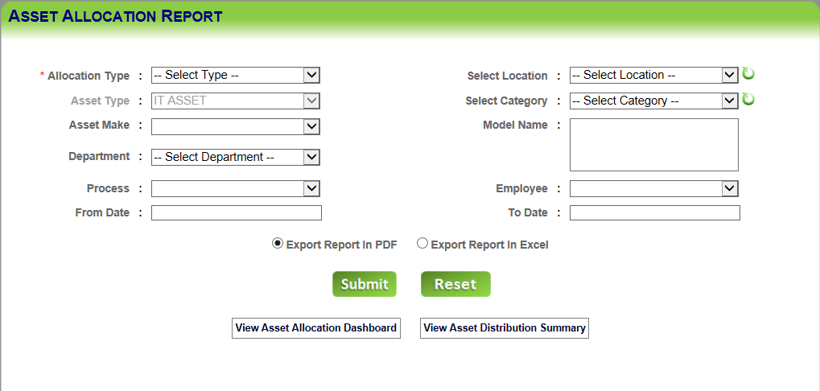

Here the user can view asset allocation report on the basis of selecting various filters like **allocation type (allocated/returned), asset type, asset make, process, employee, from date, location, category, model name and to date**.

On clicking “**Submit”**, the report will appear in the crystal report/excel sheet format as per export format selected by the user. User can also reset the data by clicking on “Reset” button after filling all the data in the text boxes.

User can also export the report data into pdf/excel file format through “Export” option. The asset allocation dashboard report can be viewed by clicking on “View Asset Allocation Dashboard” button. The report displays as below:

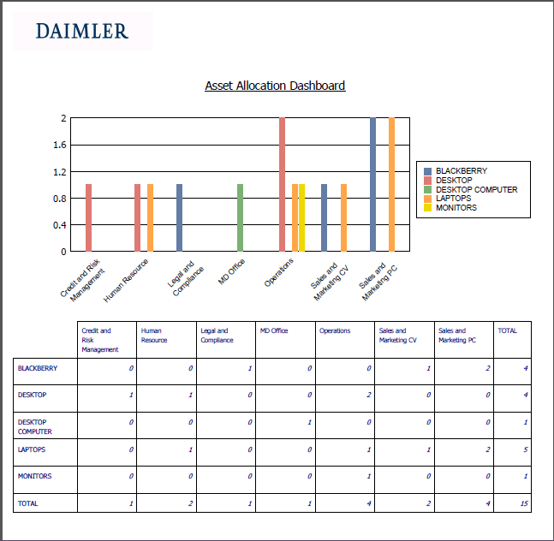

Also, single asset category distribution summary report can be viewed by clicking on “View Asset Distribution Summary” button. The report displays as below:

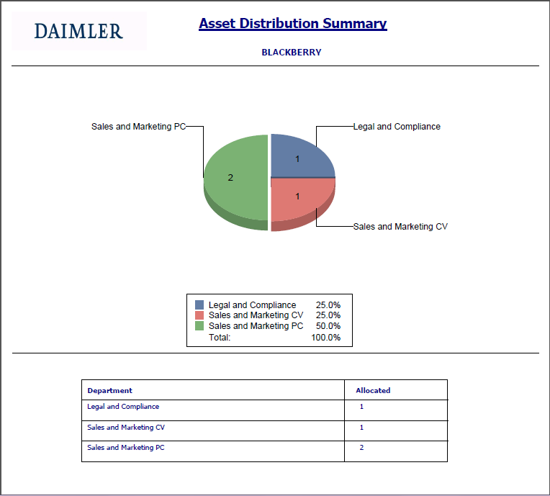

### In Stock Report

**Report 🡪 Asset Stock Report:** This screen is to view the asset stock report.

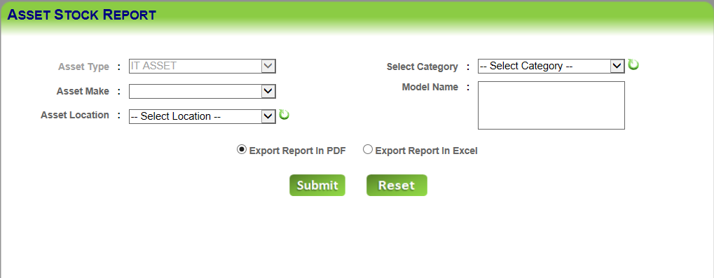

Here the user can view the asset in-stock report (assets which are in STOCK process) on the basis of selecting various filters like “**asset type, asset make, asset location, category, model name**”.

On clicking “**Submit”**, the report will appear in the crystal report/excel sheet format as per export format selected by the user. User can also reset/clear the data by clicking on “Reset” button after entering/selecting the filters.

### Tracking Report

**Report 🡪 Asset Tracking Report:** This screen is to view the asset tracking report.

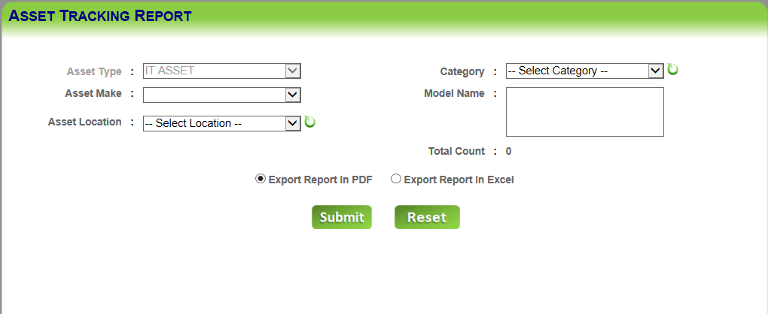

Here the user can view assets’ other details on the basis of selecting various filters like “**asset type, asset make, asset location, category, model name**”.

On clicking “**Submit”**, the report will appear in the crystal report/excel sheet format as per export format selected by the user. User can also reset the data by clicking on “Reset” button after filling all the data in the text boxes.

### Asset Summary Report

**Report 🡪 Asset Summary Report:** This screen is to view the asset summary report.

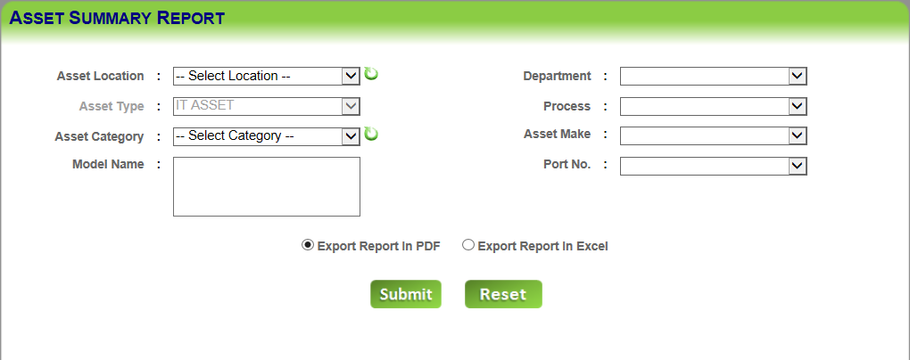

Asset summary report can be viewed through the above screen which displays assets count of different categories, Location, Department, Process (allocated), Port No., Asset Make and Model Name. On clicking “**Submit”**, the report will appear in the crystal report/excel sheet format as per export format selected by the user. User can also reset the data by clicking on “Reset” button after filling all the data in the text boxes.

### Asset History Report

**Report 🡪 Asset History Report:** This screen is to view the asset history report.

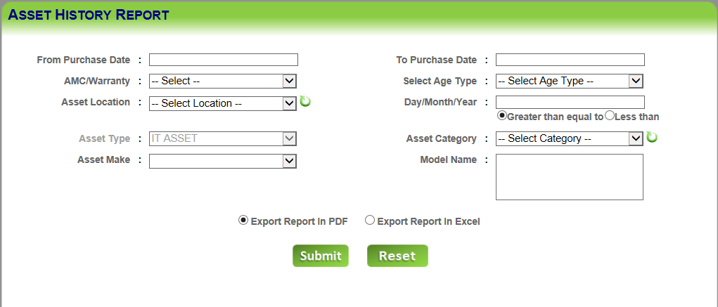

In asset history report, assets’ age is displayed on the basis of age type provided and entering Day/Month/Year in numeric value in the respective textbox. On the basis of other filters, asset history report is fetched and viewed in crystal report/excel file format.

On clicking “**Submit”**, the report will appear in the crystal report/excel sheet format as per export format selected by the user. User can also reset the data by clicking on “Reset” button after filling all the data in the text boxes.

### Asset Dashboard Report

**Report 🡪 Dashboard Report:** This screen is to view the asset dashboard report.

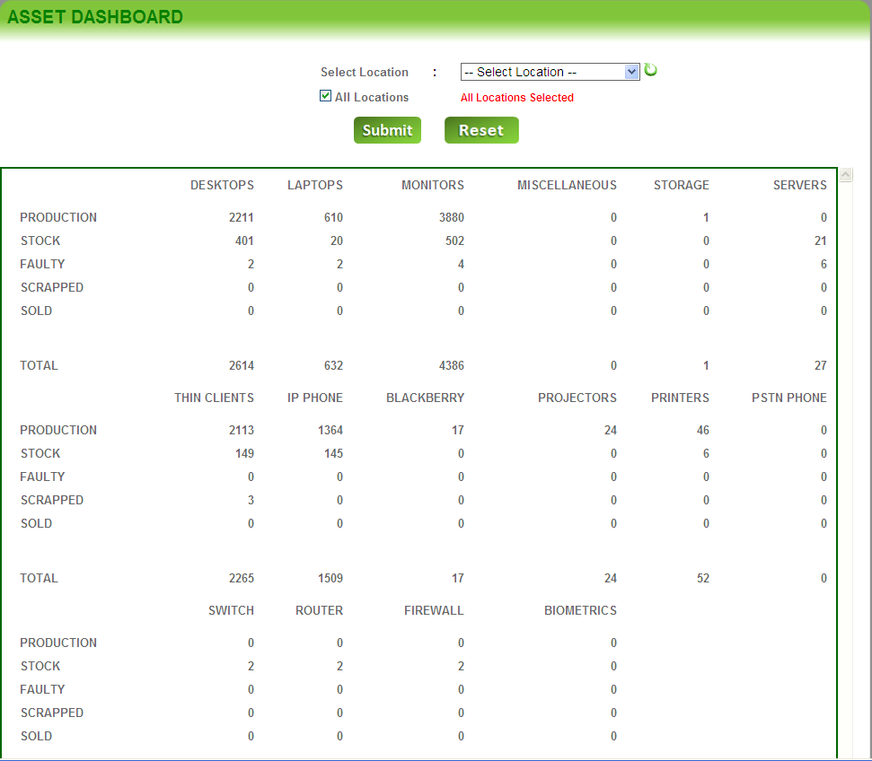

In the Asset Dashboard report, assets’ count is displayed based on asset category. Assets’ count can be viewed for all locations at the same time and for each location as well. Total assets’ count can also be viewed as per location selected. On clicking “**Submit”**, the report will appear in the table below. User can also reset the data by clicking on “Reset” button after selecting the location from the drop down list.

### Vendor Call Log Report

**Report-> Call Log Report:** This screen is to view the vendor call log report.

Here the user can view the **vendor call log report** on the basis of selecting various filters like “**vendor name, call no., call log no., etc**”.

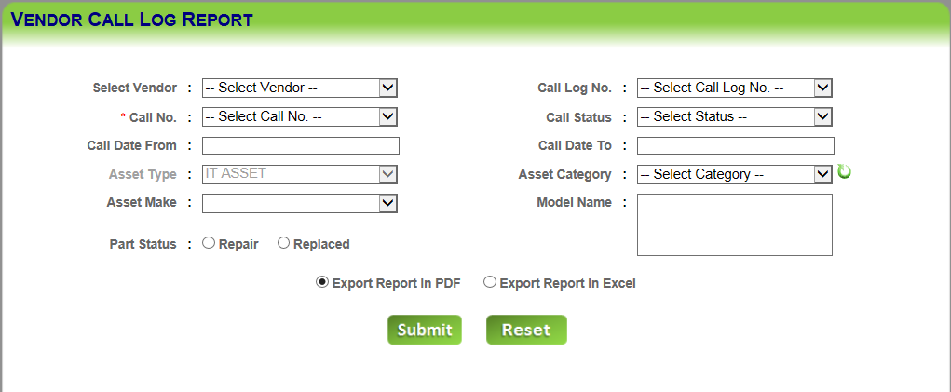

On clicking “**Submit”**, the report will appear in the crystal report/excel sheet format as per export format selected by the user. User can also reset the data by clicking on “Reset” button after filling all the data in the text boxes.

### Allocated Assets Return Status

**Report 🡪 Allocated Returnable:** This screen is to view the assets allocated return status.

Here the user can view the **allocated assets return status** on the basis of selecting various filters like “**asset type, asset make, asset process, category, model name, etc**”.

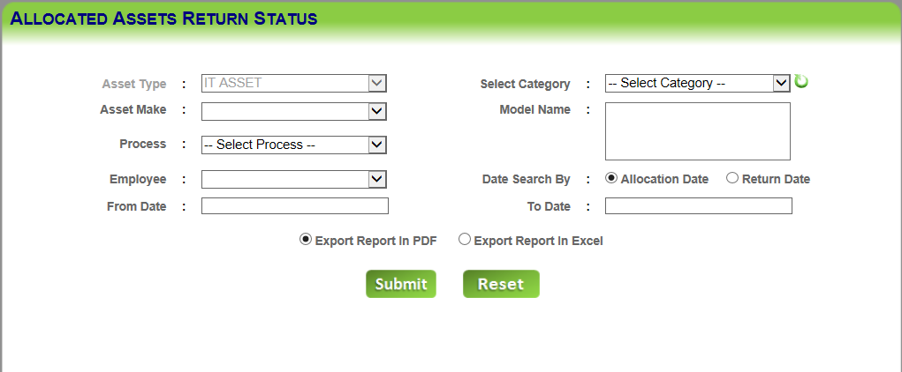

On clicking “**Submit”**, the report will appear in the crystal report/excel sheet format as per export format selected by the user. User can also reset the data by clicking on “Reset” button after filling all the data in the text boxes.

### Gate Pass Report

**Report 🡪 Gate Pass Report:** This screen is to view the gate pass report.

Here the user can view the gate pass report on the basis of selecting various filters like “**location, gate pass no., gate pass type, etc.**”

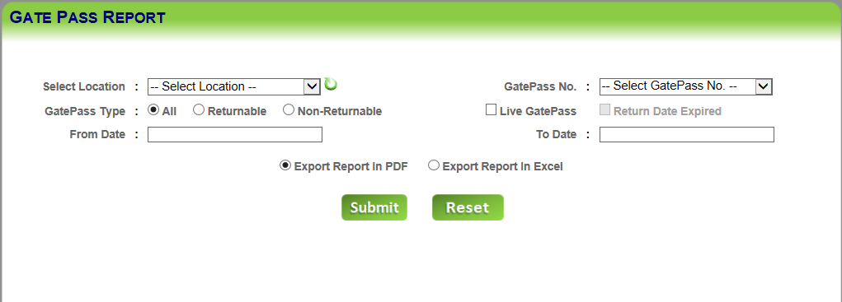

On clicking “**Submit”**, the report will appear in the crystal report/excel sheet format as per export format selected by the user. User can also reset the data by clicking on “Reset” button after filling all the data in the text boxes.

### Returnable Asset Report

**Report 🡪 Returnable Assets:** This screen is to view the returnable asset report.

Here the user can view the returnable asset report on the basis of “**returnable date expired”.**

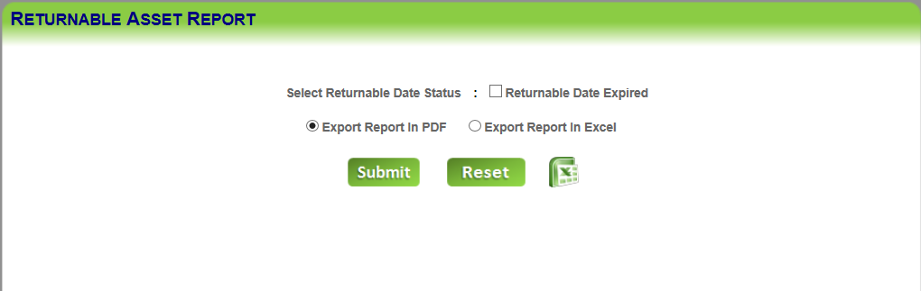

On clicking “**Submit”**, the report will appear in the crystal report/excel sheet format as per export format selected by the user. User can also clear/reset fields’ data by clicking on “Reset” button.

## Logout

User logs out from the application. The user session gets expired and the web page is redirected to the user login page for fresh user session.